James R. Holt, Ph.D., PE
Associate Professor Engineering Management
Washington State University
Feel free to use this game when you credit to the source.

The JOB SHOP GAME

Instructor Information

Objective of Game
- The student will be able to understand how Drum-Buffer-Rope (DBR) scheduling applies to Job Shop environments.

Overview:
- The game is played by releasing 20 to 40 Job Order Cards, one at a time, into the shop and sending them through four different Work Centers (A - D) to make the product. The Orders are monitored to determine how long it takes to get an Order processed from start-to-finish (flow time). The flow days are recorded on a chart. The results are analyzed.
Background:
- In a Job shop environment, machines are organized in a functional layout (machines with similar processing characteristics are grouped together in a Work Center). Each Order that is released follows a specific routing (a processing sequence) through the Work Centers.

- With the high variety of routings and loads (setup and run times), you have a complex environment which is extremely hard to schedule. The bottlenecks (constraints) seem to constantly shift, making it difficult to determine when Orders will be completed.

- Even though Job Shop environments range from ‘High Variety / Low Volume’ (Unique One-of-a Kind, ex. a tooling shop), to ‘Lower Variety / Higher Volume’ (ex. a production shop where the parts for a set of products are made in batches on a regular basis), this exercise effectively demonstrates the applicability of DBR to all Job Shop environments.

Work Centers & Capacity:
- For this exercise, our Job Shop has four (4) Work Centers (A - D) and each Work Center has one machine. The processing capability of each Work Center is specialized, so you can’t use alternate routings.
- Each machine has only enough capacity to perform one operation per day.
Products:
- There are Job Order Cards are different for each product. Each product has four operations but the operations and the order of operations is different for each product.

- For the student who works in a High Variety / Low Volume environment, you can consider these as four product TYPES represented by the Product # (1 - 4) [ex. four different types of tools]. Each Order card represents a UNIQUE PRODUCT [tool] within each product type.

- For the student who works in a Lower Variety / Higher Volume environment, you can consider these as four different PARTS represented by the Product # (1 - 4). Each Order card represents a different BATCH of each part.

Routings:
- The process Routing, which represents the necessary sequence of Operations (the Work Center where each operation is to be performed) is on the Job Order Card. Orders must be processed by the Work Centers in the same sequence as the Routing.
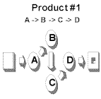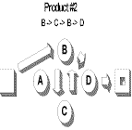

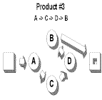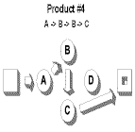

Role Requirements: The Instructor should assign students to be the Scheduler, Work Center Operators, and Flow Control Monitor roles. The roles have the following requirements:

- Scheduler(one person) - This game requires the Scheduler to release the work according to the schedule. Each day the Scheduler writes the day the Job Shop Card was release in on the Release Day Line. The Scheduler will also have to keep track of how much work is int the system (be able to add up the buffer count ) and determine whether to release an order during the different versions of the Job Shop Game.

- Work Center Operator(four people) -There is one person at each Work Center (A, B, C or D). These Operators can perform one operation per day. If they have work, the Operator can write a number in one "Day Complete" box. This counts as the operation. In some scenarios of the game, the Operator will report certain information to the Scheduler. For example, in scenario 3, the operators are required to indicate the number of ‘B’ operations that have not been completed on the orders in their queue at the end of each day. This is easily done by indicated by either a closed fist for none, or the appropriate number of fingers.

- Flow Control Monitor(one person) - The Flow Control Monitor takes all completed products and calculates the Total Flow days (the date in the last Day Complete box minus the Release Day). The Flow Control Monitor records the Total Flow Days in two places. One is the Orders By Release Day Chart (where the Flow Time is plotted opposite the release day) and the other is the Flow Time Distribution Chart where a histogram is kept showing the number of Job that that were completed at a specific number of Flow Days. Its best if the Flow Control Monitory can work and record as the days pass , but it is OK to accumulate work and record all the measurements at the end.

The Players & Duties:
- The Instructor: The Instructor controls the speed of the game by calling out the Day and instructing Operators to work and then specifying when the operators transfer work from one Work Station to the next.
- Scheduler: When the Instructor calls out "Shop Day ...", the Scheduler makes a decision to Release/Not Release an Order card according to the specific scenario instructions. When the Instructor calls out "Write...", and the Order is going to be released, the Scheduler writes the Shop Day on the ‘Release Day’ line on the Job Order Card. When the Instructor calls out "Pass...", the Scheduler passes the Order card to the first Work Center listed on the Job Order Card. There may be a queue of work at that location.(the first Operation).
- Work Center Operators: Each Work Center can only process a maximum of one operation per day. When the Instructor calls out "Shop Day ...", the Operator takes ONE Order card from their queue (if the Work Center has Job Order Cards awaiting work). When the Instructor says "Write, "the operators writes the Shop Day in the Day Complete box opposite the name of their operation. When the Instructor calls out "Pass...", the Operator passes the Order card on to the next scheduled Work Center according to the routing on the Job Order Card. If the product is finished, the card is given to the Flow Control Monitor.
- Flow Control Monitor : Calculates the flow days for each completed Job Order Card by subtracting the Release Day from the Shop Day written in the last ‘Day Complete' Box and writes the flow days on the ‘Total Flow Days’ line on the Job Order Card. When each Scenario is complete, the Flow Control Monitor also plots the data from the Order cards - see Data Plotting instructions.

General Instructions:
- The Instructor controls the rate of play and will call out Shop Days until all the Orders have been completely processed. Students will follow the cadence and not work ahead.

Preparing the Students:
- In order to have the students perform the exercise correctly, the Instructor must make sure that the students understand what to do and when to do it. Clearly explain the responsibilities of each role and how to properly record data on the ‘Order card’ and Flow Days charts.

Also, the students must understand that they are not to work ahead or fall behind. Everyone must be in sync --working on the same day-- or the exercise will not demonstrate the desired points. Possibly consider explaining, "The Instructor is like a Conductor and everyone must follow the beat or the resulting sound will not be beautiful music - just a lot of noise."

Managing the Queue:
- The Instructor can help the students learn what is important by giving subtle instructions on playing the game. For example, when the Job Order Cards are transferred from one Work Center to another, the Instructor may say, "All new work must go on the top of the pile. When you receive new work, put it on the top of any other work you have and work from the top down." Such an instruction is the same as First In-Last Out. Or, the Instructor may say, "When you receive new work, put it on the bottom of the pile of pending work." This is the same as ‘First-In-First-Out’ (FIFO) sequence. Or, the Instructor may allow the Work Center Operators to make their own choice of priorities on which job to do similar to what they do on the shop floor. The operator may see another operator needs work and process Job Order Cards in an order to help the system keep busy. The instructor may choose to not say anything and let the student handle work in random order. Any system seems to work. LIFO yields the worst histogram. FIFO produces the best histogram. But any system that does not hold back the release of work is clearly not satisfactory.

The Job Order Card:

Below is an example of the Order Card. It contains the following items:
- Product or Part: Labeled #4

Release Day (Shop Day): When the Instructor calls out "Shop Day ...", the Scheduler makes a decision to Release/Not Release an Order card according to the specific scenario instructions. When the Instructor calls out "Write...", and the Order is going to be released, the Scheduler writes the Shop Day on the ‘Release Day’ line on the Order card.

Routing Box/Shop Day: When the Instructor calls out "Shop Day ...", the Operator takes ONE Order card from their queue (if there are any Order cards in the queue), writes the Shop Day in the appropriate ‘Routing Box’ on the Order card. This is the day that operation is completed.

Routing Order: The sequence of operations for this Job Order is listed on the left side of the card. For Product #4, the sequence is First Operation A, Second Operation B, Third another Operation B and last Operation C. While there are two Operation B activities, they must be done on different days.

The Total Flow Days line is the difference between the Last Operation Day (the day Operation C completed for this card) minus the Release Day: When the order is completed, the Flow Control Monitor will calculate the flow days for each Job Order Card and mark the results on the two charts.

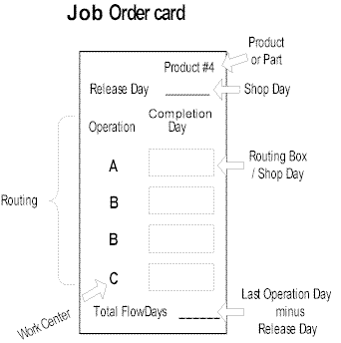
Scenario Instructions:

- Scenarios Overview:
  - The first two scenarios are run in a Traditional Job Shop scheduling manner releasing one new Job Order Card each day. Scenario #2 is a traditional job shop scheduling, but there is an attempt to 'optimize' work flow processes by trying to schedule which job comes when. Scenario #2 takes a lot of mental effort and may be skipped if time is short. Scenario #3 is a Drum-Buffer-Rope environment.

- Scenario #1 Instructions:
  - The teacher makes 5 to 10 copies of the basic Job Order Sheets (Products 1-4 on one page) and cuts them into individual Job Order Cards.
  - The Scheduler should first shuffle the Job Order Cards into random order. The Scheduler will release one Order card each Shop Day until all Order cards have been released.
  - For each Shop Day, the Instructor will:

- Call out the Shop Day (ex. "Shop Day #7")
- Pause, then tell the students to write the number of the Shop Day (ex. "Write #7") on the next Order card in their queue waiting to be processed. Note: There are several ways the student at a Work Center can approach working on the Job Order Cards that tend to queue up in front of the Work Center. The first is First-In-First Out (FIFO). Here the student puts new cards at the bottom of the stack. Another is to put the newest card received on the top of the stack (Last-In-First-Out LIFO). The student could also try to pull from the queue of available cards and work on the job that passes work quickly to an idle Work Center. Or, the student could pull the cards at random. There is not much difference with any of these approaches iin the long run. And as an instructor, you may not be able to control how the student actually does it. So, don't worry too much. But, if you have a choice, use the LIFO method. This mimicks a pile of work (new work is put on the top and work is drawn from the top) common in reality. LIFO also produces the worst distribution hence accelerating the learning process.
- Pause, then tell the students to pass the Order card to the next Work Center on the Routing or to the Flow Control Monitor if the Order is finished (ex. "Pass the Order card")
- At completion, record the data. (See ‘Data Plotting Instructions’)

- Play continues even after Scheduler releases all the cards to the system. Continue until all the cards are complete.
- At the completion, discuss with the students:

  - Examine the plot of Flow Time versus Release time and the histogram of Number of products completed for each flow time.
  - Ask, "What would have happened if we had continued releasing work to the system (rather than stopping release when we ran out of cards?"
  - Ask, "Who Accurately could you Promise Customer Delivery?"
  - If you released a Job Order Card at time 25, when would you expect it to be complete?
    - Why couldn't you produce more?
    - Why couldn't you be faster?
    - Why were you not predicable?
    - What changes did you see in the system from beginning to the end?
    - What level of Chaos did you feel?
    - How would you compare your capacity to your deliver y capability?
    - Comment on the Work-In-Process Inventory level

- Scenario #2 Instructions:

- The teacher makes 5 to 10 copies of the basic Job Order Sheets (Products 1-4 on one page) and cuts them into individual Job Order Cards.\
  - The Scheduler, with the help of the other members of the team, tries to use intuition and thought about the different Job Order Routings and tries to sequence the Job Order Cards in a very thoughtful way in an effort to create a very predictable deliver time. The effort should try to help the bottleneck Work Center (‘B’) so it is not so plugged up with Inventory. The Scheduler will continue to release one Order card each day just as in Scenario #1.

  - For each Shop Day, the Instructor will:
- Call out the Shop Day (ex. "Shop Day #7")
- Pause, then tell the students to write the number of the Shop Day (ex. "Write #7") on the next Order card in their queue waiting to be processed. Allow the students to determine the best way of handling the queue of cards they may receive. They can decide as a group or let individuals decide on their own.
- Pause, then tell the students to pass the Order card to the next Work Center on the Routing or to the Flow Control Monitor if the Order is finished (ex. "Pass the Order card")
- At completion, record the data. (See ‘Data Plotting Instructions’)
  - Play continues even after Scheduler releases all the cards to the system. Continue until all the cards are complete.
  - At the completion, discuss with the students:
    - Did you see any marked improvement?
    - Was your heavy duty thinking worth much?
    - Were you more predicable?
    - Was there any real improvement ?

- Scenario #3 Instructions:

  - The teacher makes 5 to 10 copies of the basic Job Order Sheets (Products 1-4 on one page) and cuts them into individual Job Order Cards.
  - An explanation of Drum-Buffer-Rope (DBR) is given before the third scenario is run. Depending on the depth of the knowledge the students have of DBR, they may be able to analyze the results of the previous exercises and make a determination of the correct buffer size. If not, the Instructor will have to give an explanation and guidance. The buffer size should be no less than 4 and no greater than 6. See the ‘Observations/Results’ for Scenario #3.
  - The Instructor will ensure that the Scheduler arranges the Order cards in the same release sequence as Scenario #1. (That is, the Instructor gets a clean set of Job Order Cards and puts them in the same order as the random set from Scenario #1. This is done by examining the previous release dates. If you wish, you can reuse the same cards as used in Scenario #1 and have each person write with a different color pen.). Explain to the students that the reason you are using the exact same sequence is to provide a direct comparison of results between the two scheduling methods. The Scheduler will release orders into the shop based on how much work is in the buffer. The amount of work in the buffer is defined as the number of Work Center ‘B’ operations which have not been completed for all Order cards on the shop floor. At the beginning of each Shop Day, when the Instructor says "Buffer Count", the Scheduler will count all the number of ‘B’ operations which have not yet been completed no matter where they are located (include uncompleted B work on cards at the other Work Centers also). If the number of ‘B’ operations yet to be completed is less than the buffer size, the Scheduler will plan to release one Order card. If the number of ‘B’ operations is equal to or greater than the buffer size, the buffer is considered full and no Order card is released
  - For each Shop Day, the Instructor will:
- Call out "Buffer Count" and the students will raise one finger for each ‘B’ operation which has not been completed on the Orders in their queue - use a closed fist if they have none. The Scheduler will count the fingers and make a determination of whether or not to release an order for the day.
- Pause
- Call out the Shop Day (ex. "Shop Day #7")
- Pause, then tell the students to write the number of the Shop Day (ex. "Write #7") on the next Order card in their queue waiting to be processed. Note: Now is a good time to explain what Priority Means in DBR. Tell the students the Priority is determined by the market. And, that means the earliest started job has the highest priority. So should they have a queue of jobs, they should stack them with the EARLIEST RELEASE DATE on the top. This way, the oldest job in the system is moved most quickly through the system.
- Pause, then tell the students to pass the Order card to the next Work Center on the Routing or to the Flow Control Monitor if the Order is finished (ex. "Pass the Order card")
- At completion, record the data. (See ‘Data Plotting Instructions’)
  - At the completion of the third scenario, compare the results to the first two scenarios in the same terms used in Scenario #1.
  - Did the last job complete Scenario #3 about the same day as in Scenario #1 and #2?
  - What is the slope of the Trend Line for Flow time versus Release Day?
  - What is the difference in the shape of the Histograms?
  - Which is more predictable? Why?
  - Was any work lost because of tying the Rope?
  - What is the level of Chaos in the DBR solutions?
  - What was the level of Work-In-Prograess.

- Data Plotting Instructions: There are two charts for plotting Order card data (see examples below).
- Number of Flow Days vs. Order Release Days (in Release Day sequence)’ (top chart). This chart represents the number of Total Flow Days for each Job Order Card shown in sequence of the day released.
    - Arrange the Order cards in sequence by Release Day. Each order will have its own column.
    - Plot the ‘Total Flow Days’ by putting an ‘X’ in the appropriate column at the ‘Total Flow Days’ height.
    - ex. the ninth Order released had Total Flow Days = 15.
2. No. Of Orders vs. Flow Days (Distribution)’ (bottom chart). This chart represents the number of Order cards that have the same number of Total Flow Days.
- For each Order card, put an ‘X’ in the column (starting at the bottom of the chart and working up 1, 2 , 3 and so on) representing the ‘Total Flow Days’ for each order.
- ex. Six orders had Total Flow Days = 7

Traditional Scheduling Example
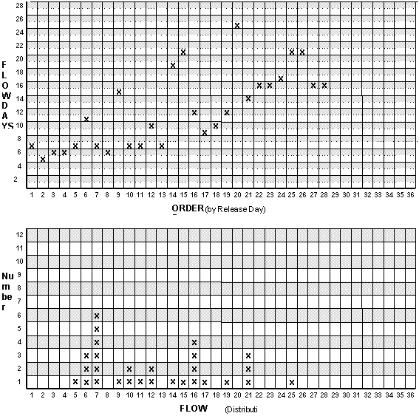

Summary

Observations / Results:

- Scenario #1: Using the traditional scheduling techniques, the first orders are processed in 4 days, but as more orders are released, the flow time increases and becomes highly variable, making prediction of completion day a risky proposition. So we see students adding a lot of padding to to protect their promised delivery. This results in lead times for the Customer getting longer and still missing delivery dates. In addition, WIP inventories continue to increase in front of the bottleneck Work Center (‘B’).

- Scenario #2: Again, the results are about the same as Scenario #1. There will be no significant improvement and maybe even slightly worse results. (See ‘Data Plotting Instructions - Traditional Scheduling Example’)

- Scenario #3: Using the Drum-Buffer-Rope (DBR) scheduling technique, the flow days range from 4 to about 10 with the most common values (the tallest columns) of 5 and 6, if the exercise is performed correctly. This results in short lead times for the Customer and no missed delivery dates, and very little inventory in the system at any one time.
  - Note: If the buffer size is set to 4, the Constraint will occasionally run out of work, Throughput is decreased, and the flow days will be slightly lower. When the constraint runs out of work, the buffer should be increased by one. If the buffer size is 6 or higher, the inventory will be slightly higher and the flow days will increase. If the queue for Work Center ‘B’ never gets below 2, then the buffer is too big. A correctly sized buffer provides maximum Throughput with minimum Flow Days and reduced Work In Process. If the buffer is too small, Throughput is lost.

DBR Scheduling Example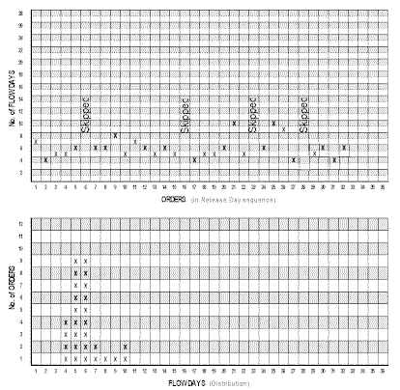

Conclusion:

- DBR is an appropriate technique for scheduling a complex manufacturing environment.

Advanced Simulations

- Luck of the Draw
  - Set up the Cards as for Scenario #1 (shuffling the cards) and play again only using DBR like for Scenario #3. Clever students will try to spend a lot of time arranging the cards into a nice sequence. They may think that the performance of the system is because of their cleverness. Of course, cleverness is not always possible in real life. By shuffling the cards in LUCK OF THE DRAW, you see that it is the DBR controls that give the predictable outcome not cleverness (although, cleverness on first release and last to release can give a slightly tighter flow day distribution when used with DBR).

- Change Over
  - Inserting DBR on the fly: Often students ask the question, "How can I implement DBR in our Job Shop?" A fun simulation is to run Scenario #1 for 20 days which builds up a healthy Queue in the system and THEN immediately implement DBR from Scenario #3 with the queue already there. You have to hold back releasing work until the selected buffer size is reached. After that, things are smooth as silk., chaos diminishes, stress is reduced and you are very predicatable. Continue playing until about 40 cards are released. The visuals show very nicely how the Flow days improve.

- Variability
  - Using Dice: After you gain proficiency in using the Job Shop Game, you may want to add more variability. The basic game is deterministic. That is, the only variability is the shuffle of the cards before the start of the game. This is not realistic. To simulate variability, you can give each Work Center a single die. Each day the Work Center rolls the die. If the roll is 2,3,4, or 5, the Work Center has productivity that day (acts normally) and can write one number (if they have work to do). If the roll is a 1, the Work Center has a bad day and is not productive at all (cannot do any work at all - cannot write a number-any work in progress at that work center just sits there). On the other hand, if the roll is a 6, the Work Center has a really good day with double production capability and can write TWO numbers (if they have that much work to do). On the average, each Work Center produces the same as with the deterministic game. But the variability is enough to upset work flow a bit. You may want to play this game yourself before working with the students. You will find that using dice both Scenario #1 and Scenario #3 perform almost the same as before only with a bit more variability in the outcomes. The parallelism is surprising. Running a good Drum-Buffer-Rope solution will give the same results for the variable model as the deterministic model.

- Batches
  - Efficiency Motive: If the students are in an environment where efficiency measures are paramount, implement Batch Processing. This is easy to do. Just tell everyone they cannot move any work from one Work Center to another Work Center unless there are Two Job Order Cards being delivered to the next Work Center. That is, you cannot pass along a card from Work Center A to Work Center D until you have TWO Job Order Cards that go from Work Center A to Work Center D. Play Scenario #1. Within 5 to 10 days, this policy will become obviously unbearable. Nothing is being produced. There is Work-in-Process everywhere. To avoid a mutiny of the students, change the Batching Policy about day 10 to a new Batching Policy, "When two Job Order Cards are completed at any one Work Center, then you can move the cards to the next Work Center (even if the Job Cards are not going to the same Work Station). For example, Work Center C performs two operations and has two Job Order Cards ready to move (one for Work Center B and one for Work Center A). Work Center C can then send one Job Order Card to Work Center B and one to Work Center A, even though it violates the Batch Size of 2." Under either of these policies, production will be terrible. Student will learn very quickly batching is not the thing to do in a Job Shop world.

- Kanban
  - Just In Time: Doing Kanban flow in a flow line is easy to watch. But, doing Kanban in a Job Shop is hard and takes a lot of careful control. If you are brave, you can try to do Kanban with the Job Shop Game as a comparison with DBR. I suggest using a Kanban size of two cards (one in process and one waiting). This way, the maximum theoretical work in process would be 8 cards. There are a lot of different possible outcomes depending upon your control of the system. In the Job Shop, cards often flow from two Work Centers to one Work Center. This leads to a decision of who gets to move there and who doesn't if the Kanban for the receiving Work Center is full. With students, this often becomes 'whoever is fastest'. As such, you can get a nice distribution with a few way out outliers. The key to running Kanban is the release of work. The scheduler calls out the day but only writes the release date if it is possible to release work on that day. Since this is similar to the rope in DBR, you will get a tight distribution of flow times. However, rather than having a safe feeling buffer, the work in process queue at Work Center B can vary drastically and often approach zero. If you play Kanban with dice, you will surely starve Work Center B once or twice in 36 cards.
- Balance Line
  - Lean Production: Some students will argue that whole problem is the B Operation. There is unbalanced Capacity. What if the work released to the Job Shop had equal work load for each work station. That is, instead of releasing six days of work for Work Center B every four days, what if in four days you released four days of work for each Work Center? Wouldn't that smooth everything out? This is the type of problem that happens in a large job shop environment where it is clear every work center has capacity to meet the market demand, and yet they still cannot seem to get things delivered on time. It turns out you can not run a Job Shop with a balanced line without tying the rope. The Job Shop just won't work. To illustrate this impact of Lean on a Job Shop, play the Job Shop Game using Job Orders Cards named Balanced #1, Balanced #2, Balanced #3 and Balanced #4. These four Job Order cards contain 4 operations for each of A, B, C and D. Copy 5-10 copies of the Order Card Sheet with Balanced #1-4 Job Orders. Cut the sheet into individual Job Order Cards making sure to have the same number of each Job Order product (1-4). Shuffle the cards. Release the work as in Scenario #1. You will be surprised at the time it takes to complete all the jobs and the huge variability in when the jobs are completed. While the Flow Times do not continually increase as they did in the earlier Scenario #1, there will me quite a few significant outliers. And, you will not be able to accurately predict when a Job Order will be delivered or be an outlier. Consequently, predictability is lost. No matter what you do, the Lean Production line will take longer to produce the same number of Jobs per day ( on the average). To remedy this, tie the rope to control the buffer. But in this case, count the number of Jobs (number of cards) released to the system as the buffer. You will get remarkable predictability. Experiment with different buffer sizes.

- Dynamic Buffering
  - Advance Buffer Management: In general, buffer sizes are fixed. But, there are some cases where it is justified to change the buffer size (adjust up and down). One such incident is when the work load on the system shifts and causes a non-constraint to become temporarily more heavily loaded than the chosen constraint for a time. When this happens, you have a choice: 1) to change the constraint of the company (not the recommended option since it changes the whole measurement system and subordination process) or 2) to increase the buffer size to accommodate the temporary change in product mix. This is a hard thing to teach and difficult for students to understand, however, with the Job Shop Game, it is easy to demonstrate. Here is how. Create another Product #5 that flows to C->A->C->D. Take the basic 36 cards and shuffle them to play Scenario #3 as usual. The scheduler will insert the Product #5 card for the Product #2 card as follows: After the tenth day (and until the 25th day), every time a Product #2 card comes up, exchange it for the new Product #5. This will shift the system constraint to Work Center C temporally. If you have too small a buffer for the real constraint (Work Center B), the buffer will not be enough to assure continued production on the constraint. Allow the students to determine how to increase the buffer size during the temporary shift in product mix such that Work Center B does not run out of work. Encourage them to return the buffer size to its original size after the day 25.

I hope you enjoy playing the Job Shop Game as much as I do. It is a robust exercise that really opens the eyes to the necessity of the rope in DBR. The cleaver instructor can use the Job Shop game (with variability) as an effective introduction to problems with Multi Tasking in Projects and the Critical Chain Project Management techniques.

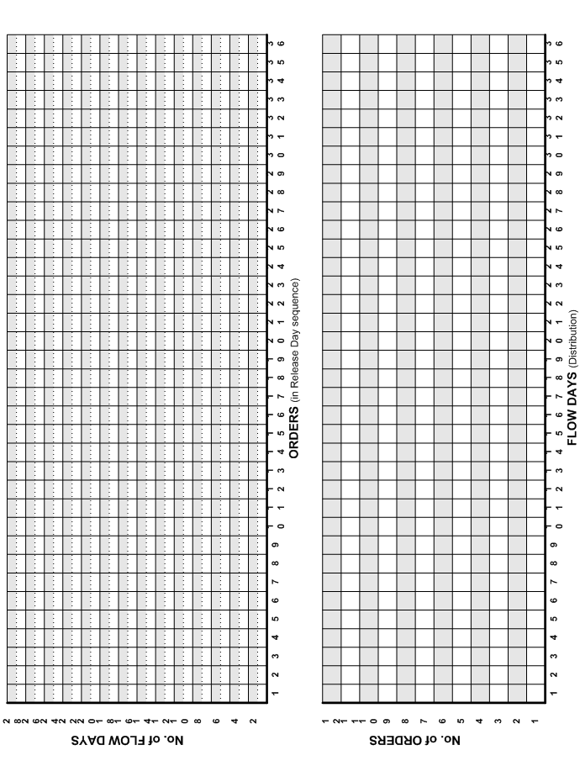
0
